Assignment 3: Data Transformation and Data Modelling
Name: Seric Sunil
Batch: 69

- Import all the three files into power bi
- Set the List of Orders table to only 500 rows.
- Change the datatype of order date to date, Amount and target to Fixed decimal number.
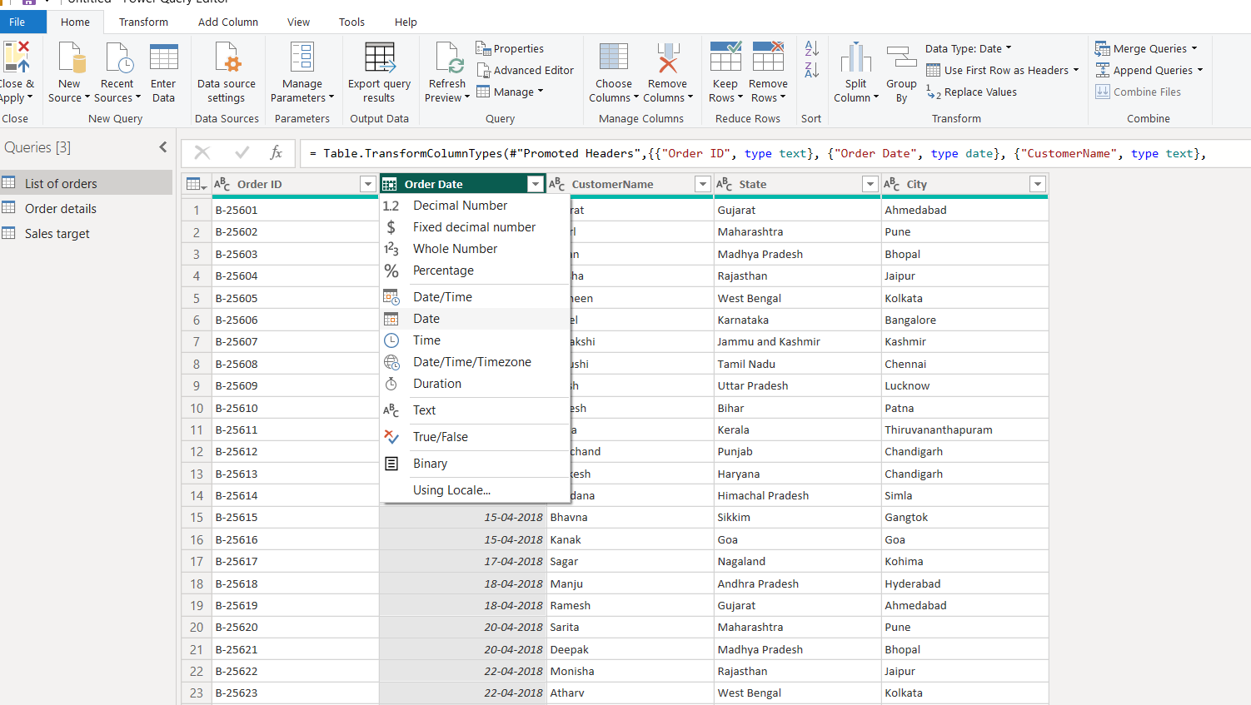
- Format customer name column to proper case using format tab.
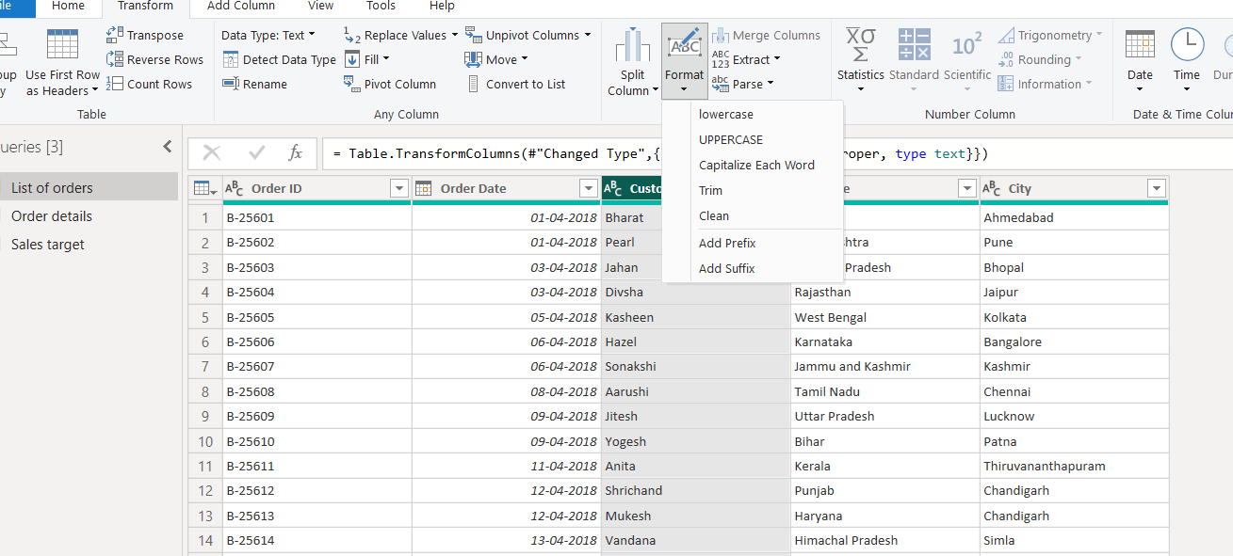
- Merge state and city column to one using Merge columns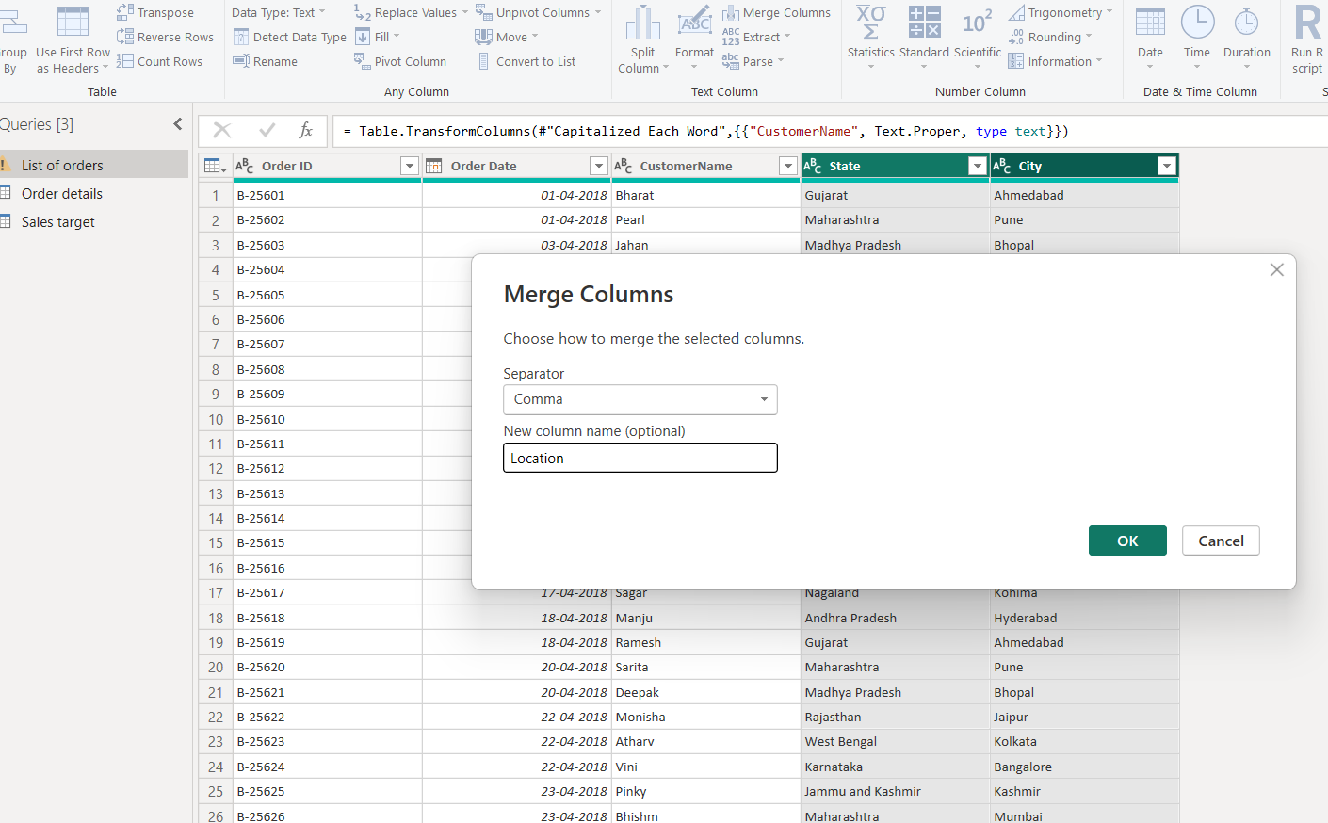
- Add two new columns using conditional column and custom column tabs.
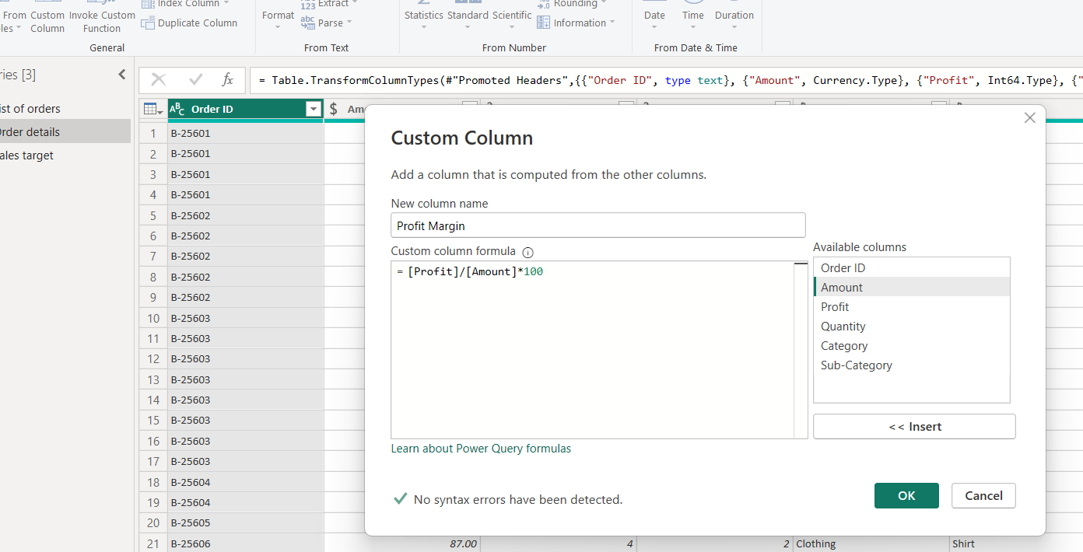
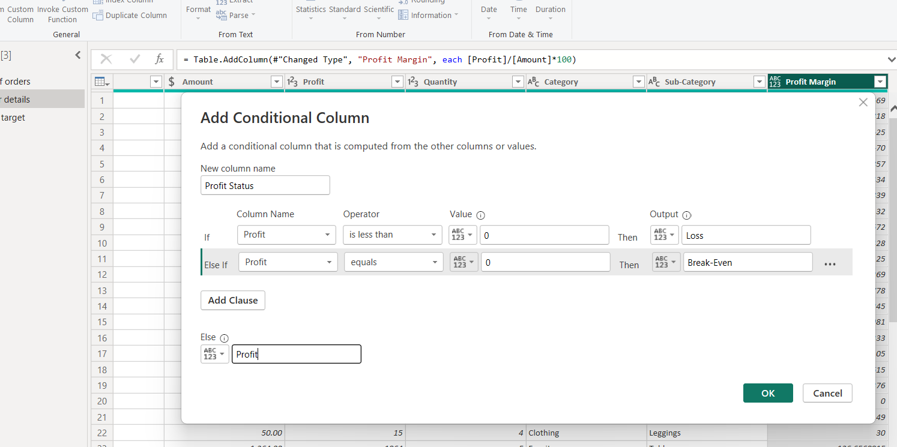

- Merge list of orders table and order details table into one using Merge tab
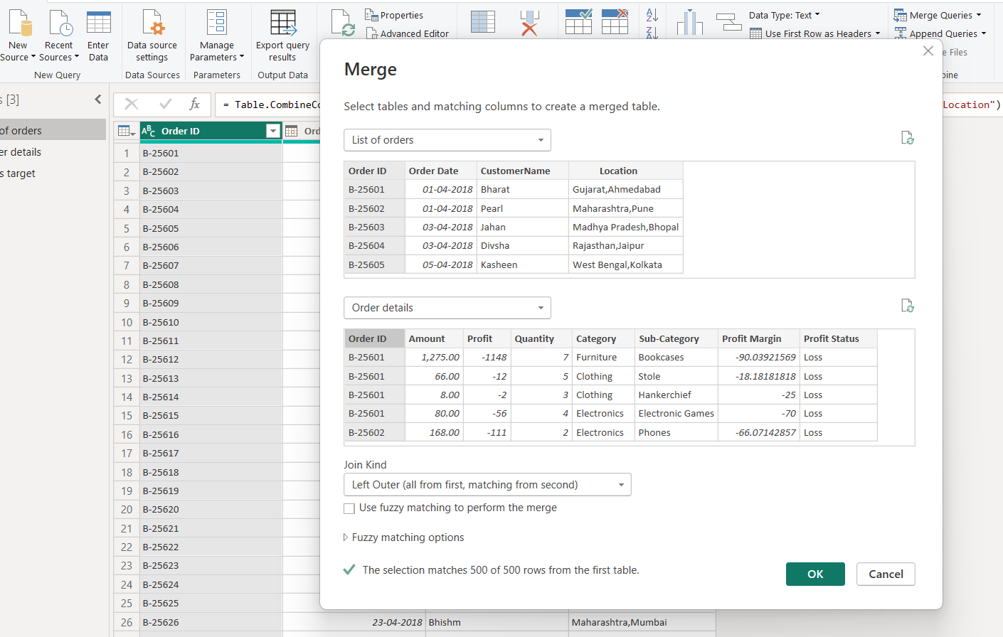
- Use sorting and filtering techniques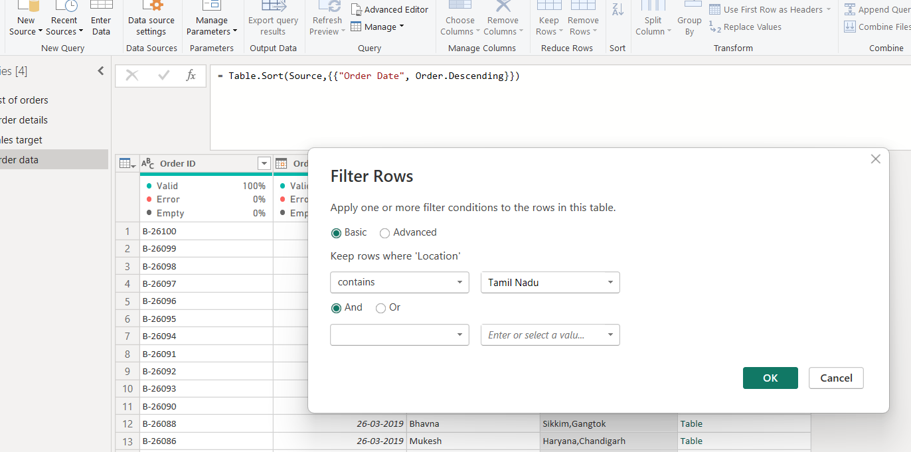
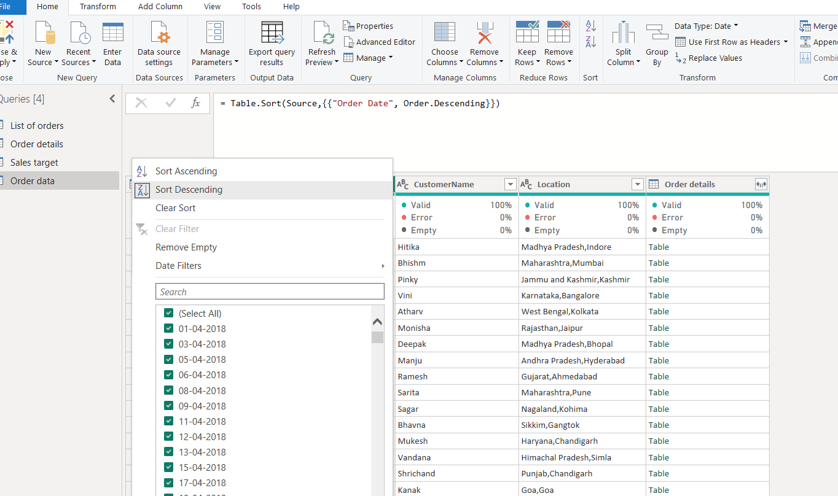
- Usage of Group by
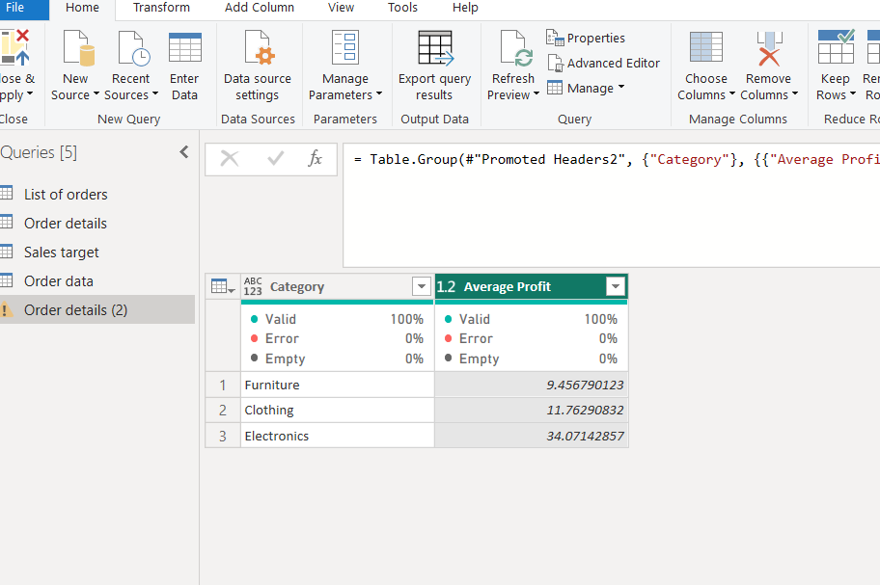
- Data Modelling is done using Manage relationships in Power bi
